Manual Handling Information
Good handling and lifting techniques should be tailored to the particular handling operations likely to be undertaken. The following guidance provides basic instruction on safe manual handling techniques:

- Plan the lift: - Stop and think; how heavy is the object, could it pose a problem when lifting (e.g. unstable contents, hot, cold, etc.)? Where is the load going to be placed (is it clear from obstruction) and is a lifting aid or assistance required?
Remove obstructions, clear a space. For a long lift, such as floor to shoulder height, consider resting the load midway on a bench or table in order to change grip.

- 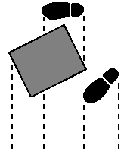Adopt a good posture and get a firm grip: - Place the feet apart giving a balanced and stable base for lifting, the leader leg placed as far forward as is comfortable.
When lifting from a low level, bend the knees (but do not kneel or over flex the knees). Keep the back straight (tucking in the chin) and lean forward a little over the load if necessary to get a good grip. Keep the shoulders level and facing in the same direction as the hips.

- Try to keep the arms within the boundaries formed by the legs. The best position and type of grip depends on the circumstances and individual preferences, but it must be secure (hook grips are less fatiguing than holding with straight fingers).
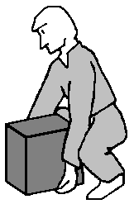

- Keep close to the load: - Keep the load as close to the trunk for as long as possible and keep the heaviest side of the load next to the trunk. If a close approach to the load is not possible, slide it towards you before lifting.

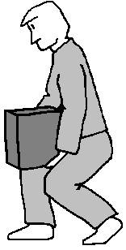

- Don’t jerk: - Carry out the lifting movement smoothly, keeping control of the load. Lift and carry with smooth rhythmical actions to avoid jerky movements that can jar your back.

- Move the load: - Do not twist the trunk when turning to the side (turn the whole body) and keep the load close to the trunk. Hugging the load can help as it creates friction with the garments (assisting in supporting the objects weight).
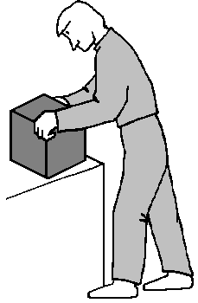

- Put down, then adjust: - If precise positioning of the load is necessary, put it down first, then slide it into the desired position. If the object is to be positioned on the floor, use the same body stance as was used to raise the object.

Pulling and Pushing Operations
For both pulling and pushing, a secure footing should be ensured, and the force applied to the load at a height between the knuckles and shoulder wherever possible. A further option, where other safety considerations allow, is to push with the handler's back against the load, using the strong leg muscles to exert the force. There is no specific limit on the distance over which the load can be pushed or pulled, providing there is adequate opportunity for rest and recovery.

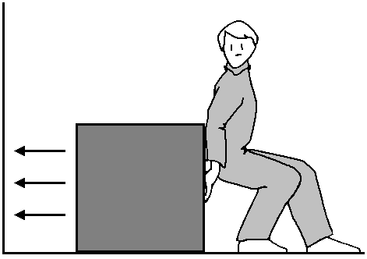

Handling while seated
Substantially less can be handled safely when seated and where possible, avoid lifting loads from the floor whilst seated. 5 kg (men) and 3kg (women) can normally be handled safely when seated (with no twisting) provided the operation is between waist and shoulder height and away from the torso.
Team handling
Where a handling operation would be difficult or unsafe for one person, handling by a team of two or more may provide an answer. For safe handling there should be enough space to access the load and the load should provide sufficient handholds. If the load is particularly small or difficult to grasp then a handling aid such as stretcher or slings should be used. One person should plan and then take charge of the operation, ensuring that movements are co-ordinated. Team members should preferably be of broadly similar height and physical capability. Where the weight of the load is unevenly distributed, the strongest member of the team should take the heaviest end.

Individual Capability
There is no threshold for ‘safe manual handling’, however it should be avoided if possible or made less demanding if reasonably practicable to do so (this will be determined by the risk assessment). The regulations governing the manual handling of loads do not lay down any maximum weight limits, instead they focus on the needs of the individual.
Individual capacity varies, even amongst the fit and healthy; some people are more able to lift loads than others. The following guideline figures for lifting and lowering are not limits, but they will give reasonable protection to around 95% of all men and women.
Guideline figures for Manual Handling
These guideline figures should not be regarded as safe weight limits for lifting and if you are in any doubt about their validity, a more detailed assessment should be undertaken. The guidelines for lifting and lowering are for relatively infrequent operations (less than 30 operations per hour) and for carrying the load against the body no less than 10m.
If the handler’s hands enter more than one box zone during the operation, the smallest figure applies. If the hands enter more than one box zone close to the boundary an intermediate figure may be chosen. If hands move out of the boundary area a more detailed assessment is required.
If the operation involves any twisting the guideline figures should be reduced by 10% for a twist through 45°, and 20% for a twist through 90°.
If the operation involves any stooping the guideline figures should be reduced by 25% for stooping through 20°, by 35% for stooping through 45° and by 50% for stooping through 90°.
If the operation is repeated frequently, the guidelines should be reduced by 30% when an operation is repeated once or twice a minute, by 50% when an operation is repeated around five to eight times per minute and by 80% when an operation is repeated more than twelve times per minute. A more detailed assessment will still be required if the worker does not control the pace, or has no opportunities to change activities or has to support the load for a length of time.

Further Requirements
Allowances should be made for pregnant employees. Manual handling has significant implications for their health and that of the foetus, particularly if combined with long periods of standing and/or walking. The risks of injury are further increased during the last three months of pregnancy, due to the difficulty in maintaining a good posture when manual handling and during the three months following the return to work after childbirth.
Individual capacity for young persons (under the age of 18 years) manually handling a load is generally less than other employees and reasonable adjustments must be made. Young persons must not undertake work, which is beyond their physical capability.
Reasonable adjustments must be made to manual handling operations to ensure disabled persons are not at any substantial disadvantage compared to non-disabled persons. This may include limiting the number, size or weight of loads handled and/or providing suitable manual handling aids.
Allowances should be made for known health problems, which may have a bearing on the ability to carry out manual handling operations in safety. If there is a good reason to suspect that an individual’s state of health might significantly increase the risk of injury from abnormal handling operations, seek medical advice.

If any injury occurs as a result of manual handling, report it to [Name].

